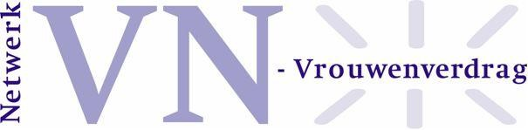
Oral Statement Dutch CEDAW Network
Geneva, 2 February 2026
Thank you, Madame Chair.

I speak on behalf of the Dutch CEDAW Network and Ieder(in). This statement is based on a joint shadow report, endorsed by 90 Dutch NGOs. We want to elaborate on two urgent issues.
First, the rise of anti-gender and anti-democratic movements. Second, gender-based violence as a structural human rights violation, highlighting intersecting forms of discrimination.

In the Netherlands, we are witnessing a growing trend of anti-gender, anti-rights, and anti-democratic movements. We urge the government to take a proactive and decisive stance in countering these developments. So far, the government has failed to do so. It requires gender and intersectionality to be explicitly named in policy. It also calls for properly supporting smaller women’s organisations through sustainable funding and more respectful systems of involvement. This would allow the full diversity of voices to participate.

The new coalition agreement pays more attention to domestic and gender-based violence. However, violence is still being treated as a series of individual incidents rather than the structural human rights violation that it is. A strong, human rights-based approach is needed. This requires stronger government coordination in response to violence against women, covering prevention, protection, and aftercare. More expertise and long-term funding are also required.
Furthermore, current strategies must explicitly include women with disabilities. Women without, or with insecure, residence status must be better protected. Policies have to ensure that all women can access support safely and without fear of deportation. The criminalisation of undocumented status should be avoided, as it is a human rights violation. Policies and services must be inclusive, accessible, and firmly grounded in a rights-based approach.

